Mathematical Language

🌟 Definition
# Source: AI Source: Provided by: [Data Path: Persons Table -> ID Column: 1, Name_En Column: Motasem Essam] -> From: [ChatGPT] on [5/29/2026]
Mathematical Language is the system of symbols, notation, terminology, and rules used to express mathematical ideas, relationships, statements, and reasoning precisely and unambiguously.
It allows mathematicians to communicate concepts in a clear and universal way, regardless of spoken language.

📚 Main Components of Mathematical Language

1. Mathematical Symbols
# Source: AI Source: Provided by: [Data Path: Persons Table -> ID Column: 1, Name_En Column: Motasem Essam] -> From: [ChatGPT] on [5/29/2026]
Symbols represent numbers, operations, relations, and other mathematical concepts.
Examples:
- + (addition)
- − (subtraction)
- × (multiplication)
- ÷ (division)
- = (equal to)
- ≠ (not equal to)
- < (less than)
- > (greater than)

2. Mathematical Notation
# Source: AI Source: Provided by: [Data Path: Persons Table -> ID Column: 1, Name_En Column: Motasem Essam] -> From: [ChatGPT] on [5/29/2026]
Notation is the standardized way of writing mathematical expressions and formulas.
Examples:
$$x^{2}+5x+6=0$$
$$f(x)=x^{2}$$

3. Mathematical Terms
# Source: AI Source: Provided by: [Data Path: Persons Table -> ID Column: 1, Name_En Column: Motasem Essam] -> From: [ChatGPT] on [5/29/2026]
Specialized vocabulary used in mathematics.
Examples:
- Number
- Set
- Function
- Variable
- Theorem
- Proof
- Matrix
- Vector

4. Logical Language
# Source: AI Source: Provided by: [Data Path: Persons Table -> ID Column: 1, Name_En Column: Motasem Essam] -> From: [ChatGPT] on [5/29/2026]
Language used to express mathematical reasoning and arguments.
Examples:
- If ... then ...
- Therefore
- For all
- There exists
- And
- Or
- Not

5. Mathematical Statements
# Source: AI Source: Provided by: [Data Path: Persons Table -> ID Column: 1, Name_En Column: Motasem Essam] -> From: [ChatGPT] on [5/29/2026]
Sentences that express mathematical facts or claims.
Examples:
- "2 is an even number."
- "Every square has four sides."
- "If x > 5, then x > 3."

✅ Types of Mathematical Language
# Source: AI Source: Provided by: [Data Path: Persons Table -> ID Column: 1, Name_En Column: Motasem Essam] -> From: [ChatGPT] on [5/29/2026]
Mathematical language can be grouped into several types or levels based on what it expresses and how it's used:

🔢 1. Arithmetic Language
# Source: AI Source: Provided by: [Data Path: Persons Table -> ID Column: 1, Name_En Column: Motasem Essam] -> From: [ChatGPT] on [5/29/2026]
- What it is: Basic language of numbers and operations
- Includes: +, −, ×, ÷, =, numbers
- Example: 4 + 2 = 6
- 📚 Used in: Early math, mental math, basic problem solving

🧮 2. Algebraic Language
# Source: AI Source: Provided by: [Data Path: Persons Table -> ID Column: 1, Name_En Column: Motasem Essam] -> From: [ChatGPT] on [5/29/2026]
- What it is: Uses variables, symbols, and operations
- Includes: x, y, a + b = c, exponents, equations
- Example: 2x + 3 = 9
- 📚 Used in: Algebra, functions, solving unknowns

📐 3. Geometric Language
# Source: AI Source: Provided by: [Data Path: Persons Table -> ID Column: 1, Name_En Column: Motasem Essam] -> From: [ChatGPT] on [5/29/2026]
- What it is: Describes shapes, sizes, angles, and positions
- Includes: Points, lines, ∠ABC = 90°, triangles, area formulas
- Example: Area = πr²
- 📚 Used in: Geometry, trigonometry, spatial reasoning

🔄 4. Functional Language
# Source: AI Source: Provided by: [Data Path: Persons Table -> ID Column: 1, Name_En Column: Motasem Essam] -> From: [ChatGPT] on [5/29/2026]
- What it is: Describes functions, their inputs and outputs
- Includes: f(x), g(t) = 2t + 1, domain, range
- Example: f(x) = x² + 1
- 📚 Used in: Algebra, calculus, modeling

🔗 5. Logical Language
# Source: AI Source: Provided by: [Data Path: Persons Table -> ID Column: 1, Name_En Column: Motasem Essam] -> From: [ChatGPT] on [5/29/2026]
- What it is: Used for reasoning, truth statements, proofs
- Includes: ∀, ∃, ⇒, ⇔, ¬, ∧, ∨
- Example: ∀x ∈ ℕ, x + 0 = x
- 📚 Used in: Proofs, logic, set theory, computer science

🔣 6. Set-Theoretic Language
# Source: AI Source: Provided by: [Data Path: Persons Table -> ID Column: 1, Name_En Column: Motasem Essam] -> From: [ChatGPT] on [5/29/2026]
- What it is: Describes collections of objects (sets)
- Includes: {}, ∈, ⊆, ∩, ∪, ∅
- Example: A = {1, 2, 3}, B = {3, 4}, A ∩ B = {3}
- 📚 Used in: Foundations of math, probability, logic

🎲 7. Statistical & Probability Language
# Source: AI Source: Provided by: [Data Path: Persons Table -> ID Column: 1, Name_En Column: Motasem Essam] -> From: [ChatGPT] on [5/29/2026]
- What it is: Describes data, chance, and randomness
- Includes: P(A), μ (mean), σ (standard deviation), probability rules
- Example: P(rolling a 6) = 1/6
- 📚 Used in: Statistics, probability, data science

🔍 8. Analytical Language (Calculus & Limits)
# Source: AI Source: Provided by: [Data Path: Persons Table -> ID Column: 1, Name_En Column: Motasem Essam] -> From: [ChatGPT] on [5/29/2026]
- What it is: Describes change, limits, continuity
- Includes: lim, d/dx, ∫, ∆x, →
- Example: lim(x→0) sin(x)/x = 1
- 📚 Used in: Calculus, mathematical analysis

📊 9. Graphical Language
# Source: AI Source: Provided by: [Data Path: Persons Table -> ID Column: 1, Name_En Column: Motasem Essam] -> From: [ChatGPT] on [5/29/2026]
- What it is: Uses graphs and diagrams to express relationships
- Includes: Coordinate axes, graphs of functions, bar charts, number lines
- Example: Graphing y = x²
- 📚 Used in: All math fields (especially functions, data, geometry)

🧩 10. Symbolic Language
# Source: AI Source: Provided by: [Data Path: Persons Table -> ID Column: 1, Name_En Column: Motasem Essam] -> From: [ChatGPT] on [5/29/2026]
- What it is: The symbols and notation system used across all types
- Includes: +, =, ∑, π, ∞, ∈, etc.
- Supports: All other types by providing consistent writing tools

🧠 Summary Table:
# Source: AI Source: Provided by: [Data Path: Persons Table -> ID Column: 1, Name_En Column: Motasem Essam] -> From: [ChatGPT] on [5/29/2026]
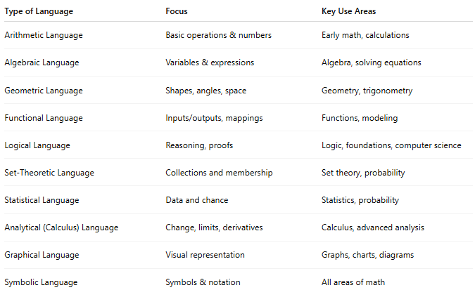

Type of Language | Focus | Key Use Areas
Arithmetic Language | Basic operations & numbers | Early math, calculations
Algebraic Language | Variables & expressions | Algebra, solving equations
Geometric Language | Shapes, angles, space | Geometry, trigonometry
Functional Language | Inputs/outputs, mappings | Functions, modeling
Logical Language | Reasoning, proofs | Logic, foundations, computer science
Set-Theoretic Language | Collections and membership | Set theory, probability
Statistical Language | Data and chance | Statistics, probability
Analytical (Calculus) Language | Change, limits, derivatives | Calculus, advanced analysis
Graphical Language | Visual representation | Graphs, charts, diagrams
Symbolic Language | Symbols & notation | All areas of math

🎯 Purpose
# Source: AI Source: Provided by: [Data Path: Persons Table -> ID Column: 1, Name_En Column: Motasem Essam] -> From: [ChatGPT] on [5/29/2026]
Mathematical language is used to:
- Express mathematical ideas precisely
- Communicate mathematical knowledge
- Write definitions, theorems, and proofs
- Describe patterns and relationships
- Avoid ambiguity and misunderstanding

🧩 Examples

Example 1
# Source: AI Source: Provided by: [Data Path: Persons Table -> ID Column: 1, Name_En Column: Motasem Essam] -> From: [ChatGPT] on [5/29/2026]
Natural Language
"The sum of two numbers is ten."
Mathematical Language
$$x+y=10$$

Example 2
# Source: AI Source: Provided by: [Data Path: Persons Table -> ID Column: 1, Name_En Column: Motasem Essam] -> From: [ChatGPT] on [5/29/2026]
Natural Language
"The area of a circle equals pi times the square of its radius."
Mathematical Language
$$A=πr^{2}$$
$$r$$
$$A=πr^{2}≈28.27$$
$$C=2πr≈18.85$$
r = 3.00

📖 Relationship to Other Mathematical Concepts
# Source: AI Source: Provided by: [Data Path: Persons Table -> ID Column: 1, Name_En Column: Motasem Essam] -> From: [ChatGPT] on [5/29/2026]
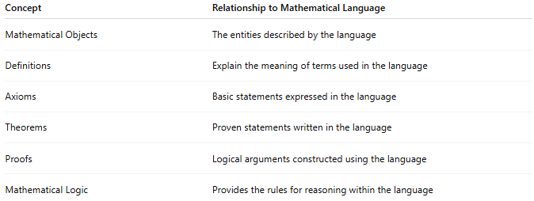
Concept | Relationship to Mathematical Language
Mathematical Objects | The entities described by the language
Definitions | Explain the meaning of terms used in the language
Axioms | Basic statements expressed in the language
Theorems | Proven statements written in the language
Proofs | Logical arguments constructed using the language
Mathematical Logic | Provides the rules for reasoning within the language

📖 Relationship Between Mathematical Language and Mathematical Objects
# Source: AI Source: Provided by: [Data Path: Persons Table -> ID Column: 1, Name_En Column: Motasem Essam] -> From: [ChatGPT] on [5/29/2026]
Mathematical Objects are the things mathematics studies.
Mathematical Language is the tool used to describe, represent, and reason about those objects.
In simple terms:
Mathematical Objects are the "things."
Mathematical Language is how we talk about those things.

📊 Comparison
# Source: AI Source: Provided by: [Data Path: Persons Table -> ID Column: 1, Name_En Column: Motasem Essam] -> From: [ChatGPT] on [5/29/2026]
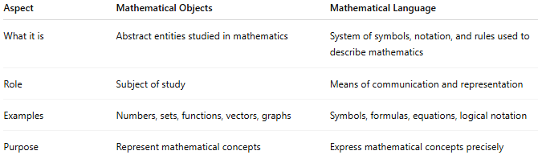
Aspect | Mathematical Objects | Mathematical Language
What it is | Abstract entities studied in mathematics | System of symbols, notation, and rules used to describe mathematics
Role | Subject of study | Means of communication and representation
Examples | Numbers, sets, functions, vectors, graphs | Symbols, formulas, equations, logical notation
Purpose | Represent mathematical concepts | Express mathematical concepts precisely

🧩 Examples

Example 1: Number
# Source: AI Source: Provided by: [Data Path: Persons Table -> ID Column: 1, Name_En Column: Motasem Essam] -> From: [ChatGPT] on [5/29/2026]
Mathematical Object:
- The number 5
Mathematical Language:
- "5"
- "five"
- $5>3$
The number itself is the object; the symbol "5" is part of the language used to represent it.

Example 2: Function
# Source: AI Source: Provided by: [Data Path: Persons Table -> ID Column: 1, Name_En Column: Motasem Essam] -> From: [ChatGPT] on [5/29/2026]
Mathematical Object:
- A function that squares a number
Mathematical Language:
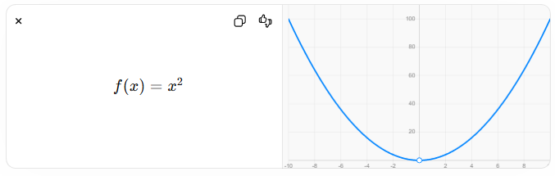
$$f(x)=x^{2}$$
The function is the object; the formula is the language describing it.

Example 3: Set
# Source: AI Source: Provided by: [Data Path: Persons Table -> ID Column: 1, Name_En Column: Motasem Essam] -> From: [ChatGPT] on [5/29/2026]
Mathematical Object:
- A set containing 1, 2, and 3
Mathematical Language:
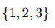
$$\left\{1 , 2 , 3\right\}$$
The set is the object; the notation is the language representing it.

🔄 Analogy
# Source: AI Source: Provided by: [Data Path: Persons Table -> ID Column: 1, Name_En Column: Motasem Essam] -> From: [ChatGPT] on [5/29/2026]
Think of mathematics like ordinary communication:
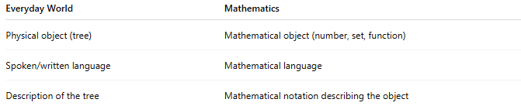
Everyday World | Mathematics
Physical object (tree) | Mathematical object (number, set, function)
Spoken/written language | Mathematical language
Description of the tree | Mathematical notation describing the object
A tree exists independently of the word "tree." Similarly, a mathematical object is conceptually distinct from the symbols used to represent it.

🎯 Why Mathematical Language Is Important
# Source: AI Source: Provided by: [Data Path: Persons Table -> ID Column: 1, Name_En Column: Motasem Essam] -> From: [ChatGPT] on [5/29/2026]
Without mathematical language, we could not:
- Define mathematical objects
- State axioms
- Write theorems
- Construct proofs
- Communicate mathematical ideas
Mathematical language makes mathematical objects understandable and usable.

🧭 Summary
# Source: AI Source: Provided by: [Data Path: Persons Table -> ID Column: 1, Name_En Column: Motasem Essam] -> From: [ChatGPT] on [5/29/2026]
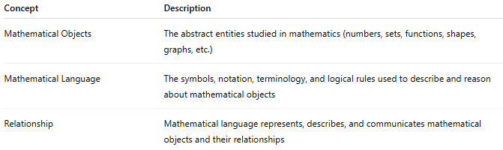
Concept | Description
Mathematical Objects | The abstract entities studied in mathematics (numbers, sets, functions, shapes, graphs, etc.)
Mathematical Language | The symbols, notation, terminology, and logical rules used to describe and reason about mathematical objects
Relationship | Mathematical language represents, describes, and communicates mathematical objects and their relationships
Mathematical language is the language used to describe, define, and reason about mathematical objects.

🧭 Summary
# Source: AI Source: Provided by: [Data Path: Persons Table -> ID Column: 1, Name_En Column: Motasem Essam] -> From: [ChatGPT] on [5/29/2026]
Mathematical Language is the universal language of mathematics. It consists of symbols, notation, terminology, and logical rules that allow mathematical ideas, objects, definitions, theorems, and proofs to be expressed clearly and precisely.

